Energy Efficient Approximate Adders Using CNFET
Gudivada Apurupa¹, P. Sai Krishna Reddy² and Sarada Musala³[0000-0002-0643-8551]
^{1,2,3} Department of Electronics and Communication Engineering, Vignan’s Foundation for Science Technology and Research, Vadlamudi, Guntur, A.P, India - 522213
¹apurupagudivada@gmail.com, ²pallerlasaikrishna111@gmail.com, ³sarada.marasu@gmail.com
Abstract. Approximate computing is to design a circuit with good accuracy by exchanging the circuit performance. The purpose is to reduce the circuit area, delay, and power. In this paper, various authors proposed various approximate adders by reducing the number of transistors. Due to a decrease in transistor number the circuit area and delay decreases compared to the exact adder. Carbon Nano-Tube Field Effect Transistor (CNTFET) technology was used for design of all the adders in this paper. All the circuits are simulated using the Cadence Virtuoso tool with 32nm CNFET technology. The supply voltage Vdd provided for these circuits is 0.9v. Here this paper discussed the Delay, Power of all approximate adder circuits. As well as the Power Delay Product of all approximate adders are also discussed.
Keywords: Approximate adder, Delay, Power consumption, Approximate Computing
1. Introduction

Nowadays, the demand for appropriate and moveable applications like mobiles, Pcs, chargers, etc. is high. Because power consumption became a crucial factor. An increase in circuit area causes the decrease in battery life of moveable applications like mobiles, PCs, chargers, etc., [1] Due to this power consumption of the devices also increased. To boost the portable device’s energy effectiveness, various approaches such as nanotechnologies and approximate computation have been implanted using crucial elements [2]. The Carbon Nanotube Field Effect Transistor (CNTFET) technology is used to construct adders, subtractors, multipliers, approximate adders, and ripple carry adders to minimize transistor count, energy usage, and circuit size. Various elements, such as supply voltage, power, delay, and power-delay product, are taken into account while determining the energy efficiency of a circuit.
The arithmetic logic circuit is a dominant part of the VLSI (Very Large Scale Integrated) and has a crucial impact on the overall performance of VLSI. Adder is the fundamental unit of VLSI. Hence, approximate adder design draws the researcher’s interest widely [2]. The method used to minimize the circuit area, delay, and power dissipation is the use of an approximate adder. The arithmetic circuits mean which bought improvements like energy, performance of a circuit, and area of the circuit in the error tolerance applications [3]. Error tolerance applications like video and image processing applications where the exactness is not much important [4].
The Carbon Nanotube Field Effect Transistor (CNFET) shown in Fig 1 is used widely in nanotechnologies in place of MOSFETs. These comprises of both n-type and P-type CNFETs. The CNTFETs are one-atom-thick layer graphene tubes that are transformed into cylindrical pipes [5]. As compared to MOSFETs switching speed is high for CNTFETs. Due to this factor the Power dissipation is low for CNFET circuits than MOSFET circuits. By altering the diameter of the CNT or the chirality vector, CNTFETs provide the chance to regulate the threshold voltage [6].
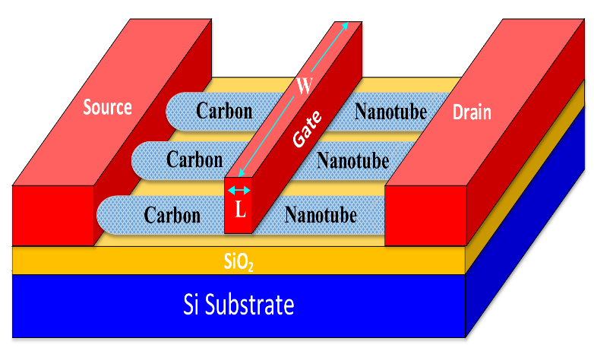
Fig. 1. Structure of CNTFET

The structure of this Paper is as follows: Chapter II addresses various existing approximate adders whereas Chapter III provides an explanation of Proposed Approximate adders. In Chapter IV the Simulation results of all the approximate adders are discussed. Finally, the conclusion is summarized in Chapter V.
2. Existing work

2.1 Approximate adder 1

The proposed Approximate Adder1 in [7] has 14 transistors and it is lesser when compared to the exact adder. This adder contains total 4 errors whereas, Sum having 3 errors and Carry contains 1 error. In equations 1 and 2, the Sum and Carry expressions are shown.
Sum= ~Carry (1)
Carry= (A . B) + C (2)

2.2 Approximate adder 2

The Proposed Approximate adder 2 in [7] has 14 number of transistors and Sum contains 3 errors and 0 errors in Carry. This adder has 14 less transistors than accurate adder. In equations 3 and 4, the Sum and Carry expressions are shown.
Sum= ~Carry (3)
Carry= (B. C)+A (4)
2.3 Approximate adder 3

Approximate adder 3 is proposed in [7] with 18 number of transistors and Sum have 2 errors where Carry contains 2 errors. This adder having the more circuit area when compared to previous adders. The Sum and Carry expressions are shown in equations 5 and 6.
Sum= ~Carry (5)
Carry= (A . B)^C (6)
2.4 Approximate adder 4

Approximate adder 4 is proposed in [7] with 14 number of transistors and contains 2 errors in Sum and carry has 0 errors. This circuit having the And or Inverter (AOI) Logic. The Sum and Carry expressions are shown in equations 7 and 8.
Sum= ~Carry (7)
Carry= AB+BC+CA (8)
2.5 Approximate adder 5

Approximate adder 5 is proposed in [4][8] with 16 number of transistors and results Sum having 2 errors and Carry contain 0 errors. This adder having more number of transistors and less errors. In equations 9 and 10, the Sum and Carry expressions are shown.
Sum’ = ABC+ $\overline{A} \overline{B}$C (9)
Carry’= ABC +AB$\overline{C}$ +$\overline{A}BC$+ A$\overline{B}$C+ $\overline{A}$B$\overline{C}$ (10)
2.6 Approximate adder 6

Approximate adder 6 is proposed in [8] with 16 number of transistors and Sum results 2 errors where Carry has 0 errors. This adder comprises 12 less transistors when compared with exact adder. The Sum and Carry expressions are shown in equations 11 and 12.
Sum = $\overline{{Carry}^{'}}$ (11)
Carry’ = AB+$\overline{A}BC$+ A$\overline{B}$C (12)
2.7 Approximate adder 7

Approximate adder 7 is proposed in [4][8] with 13 number of transistors and Sum contains 3 errors, carry contain only 1 error. Even-though it having less number of transistors but it having the more number of errors, Which causes the adder inefficient. The Sum and Carry expressions are shown in equations 13 and 4.
Sum = $\overline{{Carry}^{'}}$ (13)
Carry’ = ABC +AB$\overline{C}$ +$\overline{A}BC$+ A$\overline{B}$C+ $\overline{A}$B$\overline{C}$ (14)
2.8 Approximate adder 8
Approximate adder 8 is proposed in [4][8] with 11 number of transistors and contains 3 errors in Sum and Carry contains 2 errors a total of 5 errors which leads to adder inefficient. The Sum and Carry expressions are shown in equations 15 and 16.
Sum’= $\overline{A}\overline{B}C$+ $\overline{A}BC$ + ABC (15)
Carry’ = A (16)
2.9 Approximate adder 9

Approximate adder 9 is proposed in [9][10] with 8 number of transistors and resulting Sum containing 2 errors and Carry has 1 error. This adder was designed using Pass Transistor Logic (PTL). This designed adder having the less transistor count and less errors. In equations 17 and 18, the Sum and Carry expressions are shown.
Sum=($\overline{\text{A^B}}$)C (17)
Carry = (A^B)C+AB (18)
2.10 Approximate adder 10

Approximate adder 10 is proposed in [9][10] with 6 number of transistors and Sum contains 3 errors and Carry has 0 errors. This adder was designed using Pass Transistor Logic (PTL). How-ever it having less number of transistors but it contains more number of errors compared to previous adder. The Sum and Carry expressions are shown in equations 19 and 20.
Sum=($\overline{\text{A^B}}$) (19)
Carry= (A^B)C+AB (20)
3. Proposed work

In this paper 10 approximate adders are designed and implemented using CNTFET Technology.
3.1 Approximate adder 1

The Proposed adder was designed using equations (1) and (2) with CNTFET transistors, which is designed using Fig 2. It consists of 14 transistors. The Sum and Carry errors for Fig 2 are displayed in Table 1(a). There are three sum errors and one carry error respectively. It uses Static logic for Implementation.
carry
sum
Vdd

Vdd

C

GND
Vdd

A

B

B

A

GND
Vdd

GND
Vdd

GND
GND
GND

C

Fig. 2. Schematic of approximate adder 1

3.2 Approximate adder 2

The proposed adder was designed using equations (3) and (4) with CNTFET transistors, which is designed using Fig 3. It consists of 14 transistors. The Sum and Carry errors for Fig 3 are displayed in Table 1(a). There are three Sum errors and zero Carry error respectively. It uses Static logic for Implementation.
carry
sum
Vdd

B

C

B

C

GND
Vdd

A

A

GND
Vdd

GND
Vdd

GND
Vdd

GND

Fig. 3. Schematic of approximate adder 2

3.3 Approximate adder 3

The proposed adder was designed using equations (5) and (6), with CNTFET transistors, which is designed using Fig 4. It consists of 18 transistors. The Sum and Carry errors for Fig 4 are displayed in Table 1(a). There are two Sum errors and two Carry errors respectively. It uses Static logic for Implementation.

Vdd

GND
C

Vdd

Vdd

B

A

A

B

Vdd

- sum

Vdd
GND
GNDv
GNDvc
GNDv
Vdd
Vdd
Carry
sum

Fig. 4. Schematic of approximate adder 3
3.4 Approximate adder 4

The proposed adder was designed using equations (7) and (8), with CNTFET transistors, which is designed using Fig 5. It consists of 14 transistors. The Sum and Carry errors for Fig 5 are displayed in Table 1(a). There are two Sum errors and zero Carry errors respectively. It uses Static logic for Implementation.

C

A

B

C

A

B

Vdd

B

A

B

C

C

A

GND
GND
GND

Vdd

carry
sum
GND

Fig. 5. Schematic of approximate adder 4

3.5 Approximate adder 5

The proposed adder was designed using equations (9) and (10), with CNTFET transistors, which is designed using Fig 6. It consists of 16 transistors. The Sum and Carry errors for Fig 6 are displayed in Table 1(a). There are two Sum errors and zero Carry errors respectively. It uses Static logic for Implementation.
Vdd

C

Vdd

B

B

C

A

GND
GND

B
A

A

B

C

GND

C

B

A

GND
Vdd
carry’
sum’
GND

Fig. 6. Schematic of approximate adder 5
3.6 Approximate adder 6

The proposed adder was designed using equations (11) and (12), with CNTFET transistors, which is designed using Fig 7. It consists of 16 transistors. The Sum and Carry errors for Fig 7 are displayed in Table 1(b). There are two Sum errors and zero Carry errors respectively. It uses Static logic for Implementation.
Carry’

GND
Vddv

B

B

A

A

A

B

A

B

GND

C

GND
Sum
Vdd

Vddv

Fig. 7. Schematic of approximate adder 6
3.7 Approximate adder 7

The proposed adder was designed using equations (13) and (14), with CNTFET transistors, which is designed using Fig 8. It consists of 13 transistors. The Sum and Carry errors for Fig 8 are displayed in Table 1(b). There are three Sum errors and one Carry errors respectively. It uses Static logic for Implementation.
sum
Vdd

GND
carry’
GND
Vdd

B

A

C

A

B

Vdd

GND

B

Fig. 8. Schematic of approximate adder 7
3.8 Approximate adder 8

The proposed adder was designed using equations (15) and (16), with CNTFET transistors, which is designed using Fig 9. It consists of 11 transistors. The Sum and Carry errors for Fig 9 are displayed in Table 1(b). There are three Sum errors and two Carry errors respectively. It uses Static logic for Implementation.
carry’
GND
GND
GND

B

Vdd
A

A

C

C

A

GND
B

sum’

C

Vdd

Fig. 9. Schematic of approximate adder 8
3.9 Approximate adder 9

The proposed adder was designed using equations (17) and (18), with CNTFET transistors, which is designed using Fig10. It consists of 8 transistors. The Sum and Carry errors for Fig 10 are displayed in Table 1(b). There are two Sum errors and zero Carry errors respectively. It uses Pass Transistor logic (PTL) and MUX logic for Implementation.
AA
C
C

A

Vdd

sum
carry
B
A
A
BA

GND
BA

Fig. 10. Schematic of approximate adder 9

3.10 Approximate adder 10

The proposed adder was designed using equations (19) and (20) with CNTFET transistors, which is designed using Fig11. It consists of 6 transistors. The Sum and Carry errors for Fig 11 are displayed in Table 1(b). There are four Sum errors and zero Carry errors respectively. It uses Pass Transistor logic (PTL) and MUX logic for Implementation.
A
Vdd

A

B

B

A
C
carry

sum

Fig. 11. Schematic of approximate adder 10
Table 1(a). Truth table for approximate adders 1-5

Inputs Exact Adder Fig. 2 Fig. 3 Fig. 4 Fig. 5 Fig. 6

A B C Sum Carry Sum Carry Sum Carry Sum Carry Sum Carry Sum Carry
0 | 0 | 0 | 0 | 0 | 1 | 0 | 1 | 0 | 1 | 0 | 1 | 0 | 0 | 0
0 | 0 | 1 | 1 | 0 | 0 | 1 | 1 | 0 | 0 | 1 | 1 | 0 | 1 | 0
0 | 1 | 0 | 1 | 0 | 1 | 0 | 1 | 0 | 1 | 0 | 1 | 0 | 0 | 1
0 | 1 | 1 | 0 | 1 | 0 | 1 | 0 | 1 | 0 | 1 | 0 | 1 | 0 | 1
1 | 0 | 0 | 1 | 0 | 1 | 0 | 0 | 0 | 1 | 0 | 1 | 0 | 0 | 0
1 | 0 | 1 | 0 | 1 | 0 | 1 | 0 | 1 | 0 | 1 | 0 | 1 | 0 | 1
1 | 1 | 0 | 0 | 1 | 0 | 1 | 0 | 1 | 0 | 1 | 0 | 1 | 0 | 1
1 | 1 | 1 | 1 | 1 | 0 | 1 | 0 | 1 | 1 | 0 | 1 | 1 | 1 | 1

Table 1(b). Truth table for approximate adders 6-8

Inputs Exact Adder Fig. 7 Fig. 8 Fig. 9 Fig. 10 Fig. 11

A B C Sum Carry Sum Carry Sum Carry Sum Carry Sum Carry Sum Carry
0 | 0 | 0 | 0 | 0 | 1 | 0 | 1 | 0 | 0 | 0 | 0 | 0 | 1 | 0
0 | 0 | 1 | 1 | 0 | 1 | 0 | 1 | 0 | 1 | 0 | 1 | 0 | 1 | 0
0 | 1 | 0 | 1 | 0 | 1 | 0 | 0 | 1 | 0 | 0 | 0 | 0 | 0 | 0
0 | 1 | 1 | 0 | 1 | 0 | 1 | 0 | 1 | 1 | 0 | 0 | 1 | 0 | 1
1 | 0 | 0 | 1 | 0 | 1 | 0 | 1 | 0 | 0 | 1 | 0 | 0 | 0 | 0
1 | 0 | 1 | 0 | 1 | 0 | 1 | 0 | 1 | 0 | 1 | 0 | 1 | 0 | 1
1 | 1 | 0 | 0 | 1 | 0 | 1 | 0 | 1 | 0 | 1 | 0 | 1 | 1 | 1
1 | 1 | 1 | 1 | 1 | 0 | 1 | 1 | 1 | 1 | 1 | 1 | 1 | 1 | 1

4. Simulation results
The CNFET technology is used in this paper to simulate 10 proposed approximation adders. The simulation outcomes for each adder are listed in Table 2 below. All 10 proposed approximate adders having less delay, power and PDP compares to the existing work. From those adders Fig.11 has less number of transistors, Fig.8 has less delay, Fig.10 has less power, and Fig.10 has less PDP value. Finally, Fig.10 is suitable for approximate computing because less PDP, less delay and less circuit area.
Table 2. Delay, power and PDP values of approximate adders
S. No | Adders | No. of Transis- tors | Delay(ns) | Power(µw) | PDP
1 | Fig. 2 | 14 | 1.005 | 0.5602 | 0.563001
2 | Fig. 3 | 14 | 1.498 | 0.5607 | 0.838246
3 | Fig. 4 | 18 | 1.006 | 0.5078 | 0.574224
4 | Fig. 5 | 14 | 1.005 | 0.4518 | 0.454059
5 | Fig. 6 | 16 | 1.002 | 0.5609 | 0.562021
6 | Fig. 7 | 16 | 1.006 | 0.4521 | 0.454812
7 | Fig. 8 | 13 | 0.996 | 0.5609 | 0.558656
8 | Fig. 9 | 11 | 1.504 | 0.4484 | 0.674393
9 | Fig. 10 | 8 | 1.004 | 0.4389 | 0.440655
10 | Fig. 11 | 6 | 1.449 | 0.4431 | 0.664206

The transient responses for all the approximate adders are shown in Fig 12 and 13.
Table 3. PDP comparison of Existing Adders and Proposed Adders

S. No | Adders | Existing Technology | PDP (fJ) | Proposed Technology | PDP (fJ)
1 | Fig. 2 | gpdk180nm | 3.267398 | CNFET 32nm | 0.563001
2 | Fig. 3 | gpdk180nm | 5.333406 | CNFET 32nm | 0.838246
3 | Fig. 4 | gpdk180nm | 103.2987 | CNFET 32nm | 0.574224
4 | Fig. 5 | gpdk180nm | 43.08102 | CNFET 32nm | 0.454059
5 | Fig. 6 | gpdk180nm | 4.743280 | CNFET 32nm | 0.562021
6 | Fig. 7 | gpdk180nm | 1.341192 | CNFET 32nm | 0.454812
7 | Fig. 8 | gpdk180nm | 8.001000 | CNFET 32nm | 0.558656
8 | Fig. 9 | gpdk180nm | 6.498800 | CNFET 32nm | 0.674393
9 | Fig. 10 | gpdk180nm | 3.531528 | CNFET 32nm | 0.440655
10 | Fig. 11 | gpdk180nm | 4.741000 | CNFET 32nm | 0.664206

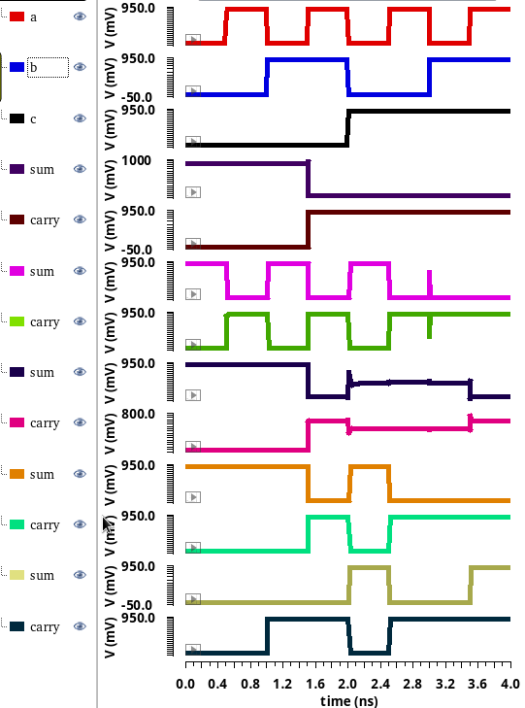
Fig. 12. Transient response of approximate adders Fig. 1-Fig. 5

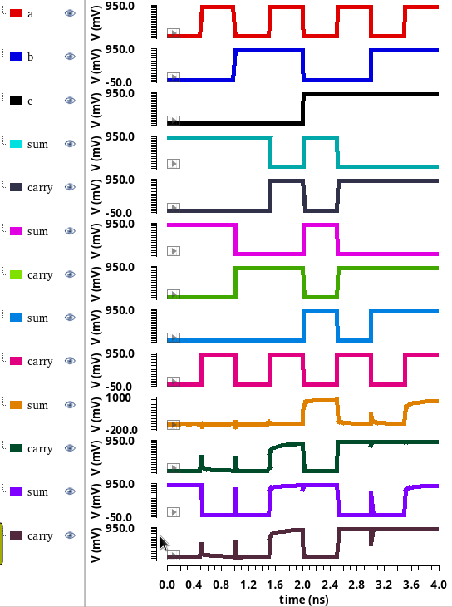
Fig. 13. Transient response of approximate adders Fig. 6-Fig. 10
5. Conclusion

In this paper, the design of various approximate adders are simulated using the 32nm CNFET technology with supply voltage of +0.9v. The Approximate adders’ simulations are done through Cadence tool. In this paper, all the Proposed and existing adders delay, power and PDP are compared. From all the above 10 different approximate adders Fig.8 having the less delay compared to all and Fig.10 has less power and less PDP. Finally, from all the above Fig.8 and Fig.10 are used for the Approximate computing technique.

References
1. Bhargav, A.; Huynh, P. Design and Analysis of Low-Power and High-Speed Approximate Adders Using CNFETs. Sensors 2021, 21, 8203.
2. W. Yang, L. Wang and K. Li, "An Approximate Adder Design Based on Inexact Full Adders," 2021 IEEE 15th International Conference on Anti-counterfeiting, Security, and Identification (ASID), 2021, pp. 154-158, doi: 10.1109/ASID52932.2021.9651713.
3. G. Ferreira, P. T. L. Pereira, G. Paim, E. Costa and S. Bampi, "A Power-Efficient FFT Hardware Architecture Exploiting Approximate Adders," 2021 IEEE 12th Latin America Symposium on Circuits and System (LASCAS), 2021, pp. 1-4, doi: 10.1109/LASCAS51355.2021.9667154.
4. V. Gupta, D. Mohapatra, S. P. Park, A. Raghunathan and K. Roy, “IMPACT: IMPrecise adders for low-power approximate computing,” IEEE/ACM International Symposium on Low Power Electronics and Design, Fukuoka, 2011, pp. 4
5. Zahoor, Furqan, Fawnizu A. Hussin, Farooq A. Khanday, Mohamad R. Ahmad, Illani Mohd Nawi, Chia Y. Ooi, and Fakhrul Z. Rokhani. 2021. "Carbon Nanotube Field Effect Transistor (CNTFET) and Resistive Random Access Memory (RRAM) Based Ternary Combinational Logic Circuits" Electronics 10, no. 1: 79. https://doi.org/10.3390/electronics10010079.
6. Roosta, E., Hosseini, S.A. A Novel Multiplexer-Based Quaternary Full Adder in Nanoelectronics. Circuits Syst Signal Process 38, 4056–4078 (2019). https://doi.org/10.1007/s00034-019-01039-8
7.M. Ramasamy, G. Narmadha and S. Deivasigamani, “Carry based approximate full adder for low power approximate computing,” 7th International Conference on Smart Computing & Communications (ICSCC), pp. 1-4, 2019.
8. V. Gupta, D. Mohapatra, A. Raghu Nathan, and K. Roy, “Low-power digital signal processing using approximate adders,” IEEE Trans. OnComputer-Aided Design of Integrated Circuits and Systems, vol. 32, no. 1, pp. 124–137, Jan. 2013.
9. Z. Yang, A. Jain, J. Liang, J. Han and F. Lombardi, "Approximate XOR/XNOR-based adders for inexact computing," 2013 13th IEEE International Conference on Nanotechnology (IEEE-NANO 2013), 2013, pp. 690-693.
10. P. A. Silva and C. Meinhardt, "Energy-Efficient Design of Approximated Full Adders," 2020 27th IEEE International Conference on Electronics, Circuits and Systems (ICECS), 2020, pp. 1-4, doi: 10.1109/ICECS49266.2020.9294925.

